A doctor's tool kit of a different kind: Notes on refashioning the master’s tools and shifting medical and pathology paradigms through play and radical softness.

Imagine a doctor’s office or hospital. The walls are warm, colourful, and soft to the touch. There are no hard or cold surfaces. The objects and furnishings are soft, squishy, and encourage stimming. What does it feel like on your skin? How does it feel to move and sit within? How can this vision be brought to life? These provocations are embodied within the work of Amy Claire Mills. Mills’ exhibition This will only hurt for a second provides essential provocations for viewers to imagine accessible cosmopolitan futures, transform ways of thinking and existing outside the pathology paradigm, embody accessibility in action and imagine playtime and softness as radical tools for systemic change, and reclamation of agency and body autonomy. This text is a selection of notes that aim to highlight some of the key provocations of Mills’ work. My hope for these notes is that they can enable you to think outside your own experience. They are a call-to-action to revise the ways we approach accessible cosmopolitan futures; futures that should be our present. In the same way Mills embodies accessibility in action through her practice, I too hope the following text can enable viewers to do so within and beyond the walls of this exhibition.

As you enter the gallery space you are greeted by a gratuitous, childlike, comical, and absurd set of doctors implements. Interspersed among these tools are phrases regularly employed by medical professionals such as “open wide”, “hold still” and “this will only hurt for a second”. The tools and phrases are bright and colourful, soft, tufted, shiny, textured, with no sharp corners or harsh edges, they look as though they have been brought to life from a child’s drawing or pulled directly out of an afternoon cartoon, or videogame. They appear strange, unfamiliar in their appearance, tools and words that exist in an alternate world, but not too distant; A sort of jamais vu or déja vu (‘Jamais vu - Definition, Meaning & Synonyms’ n.d.). A stethoscope, surgical gloves, otoscope, syringe, thermometer, reflex hammer, pills and phrases are all bigger than life size. They are caricatures of the master’s tools (Lorde 2018) ; the literal tools of the medical industry as well as the deficient language widely used by medical professionals. Mills’ refashioning of the tools and language are actions to reclaim agency and body autonomy for themselves and the viewer. By refashioning them Mills’ work actively pivots away from medical and pathology paradigms (Walker 2021). Instead of these tools and phrases being distant, invasive, hard, cold, and shallow, they are soft, warm, and playful. They invite exploration, are empowered with connection, and activated through touch. Tools typically used to probe an individual are now created to offer opportunities for stimming, comfort, expressing feeling, as well as humour. Mills’ medical tool kit embodies Audre Lorde’s provocation “the master's tools will never dismantle the master's house”. Mills is making her own tools and representations of language to provoke viewers to reconsider their experiences of touch, intimacy, and the medical and pathology paradigms. Mills’ new tool kit is soft and playfully radical.

Play and exploration are invaluable tools in human development. Since birth humans are conditioned to practice playtime, experimentation, and exploration of their surroundings. From childhood the systems that cause and perpetuate disability (Walker 2021) are embedded within playtime. For example, take the Kmart Emergency Doctors Play Set (fig.1). Albeit brightly coloured, rounded edges and reduced in size, the tools in this set, and their colour palette, mimic the function, purpose, and feelings of touch present in the doctors tool kit as we know it. Ultimately, they are still the master’s tools; indoctrination into medical and pathology paradigms. Mills’ new doctors tool kit, language included, inspires new strategies for play, touch, and intimacy. Instead of being confined to mimicry, they have their own rules yet to be discovered through softness and touch. The new doctors tool kit creates moments of intimacy.

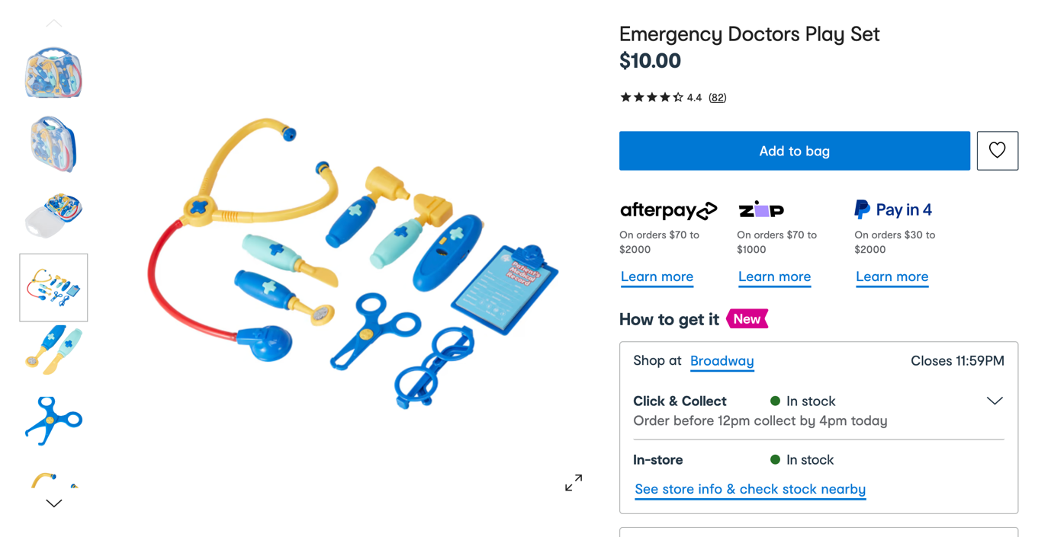
Fig.1: Screen grab of Kmart ‘Emergency Doctors Play Set - Kmart’, viewed 1 November 2023, <https://www.kmart.com.au/product/emergency-doctors-play-set-42500612/?>.

Although absurd, Mills’ refashioned tools and phrases provide a glimpse into an accessible cosmopolitan future. While not a literal representation of the future they, through their softness, offer an alternate reflection of the world and medical systems we currently exist within. This will only hurt for a second is not a definitive refashioning of the master’s tools. In the same way this text is but a glimpse at the provocations proposed to us in This will only hurt for a second. It is a work in progress, an expose on the process, as Mills leads the way into a cosmopolitan future we should have already reached.

__________________________________________________________________________________

Kieran (They/them, b. 1992, Yuin Land - Nowra, NSW) is an emerging artist, designer, and creative producer. Their practice spans across photography, graphic and fashion design, textiles and performance. Kieran’s research seeks to examine the intersections of photography, environmentalism, patchwork techniques and sustainable practices within a queer-trans-neurodivergent framework. Their work reflects on themes of queer identity and familial histories as accompanied by experiences of intimacy, vulnerability, self-awareness, love, desire, and grief. Ultimately, their practice seeks to contribute to the growing literature on queer-trans-ND lived experiences. Resources that were not readily accessible to them as a young person. They live and work across the lands of the Wurundjeri Woi Wurrung people.

k-h-b.com.au
@kiekiehbebe

Jamais vu is the feeling or experience of not being able to recognise ordinary or familiar things. This phrase is often used by medical practitioners to medicalise/pathologise this experience. The opposite of Jamais vu is de ja vu, the feeling or sense you’ve experienced something before. ‘Jamais vu - Definition, Meaning & Synonyms’ Vocabulary.com, viewed 1 November 2023, <https://www.vocabulary.com/dictionary/jamais%20vu>.
The master’s tools are the systems (health, education, economic, legal, arts, scientific etc) put in place by a dominant group, that are enforced to oppress a minority based on human difference perceived as deficits (gender, sexuality, ethnicity, disability, neurodivergence etc). Lorde, A 2018, The Master’s Tools Will Never Dismantle the Master’s House, Penguin Books Limited.
“The pathology… [and medical] paradigm can be defined by two fundamental assumptions: 1) there is one ‘right’, ‘normal’ or ‘healthy’ way for a human brains and minds… [and bodies] to be configured and to function (or one relatively narrow ‘normal’ range into which the configuration and functioning of human brains and minds… [and bodies] ought to fall). 2) If your neurological configuration and functioning (and as a result, your ways of thinking and behaving) diverge substantially from the dominant standard of “normal”, then there is something wrong with you. Walker, N 2021, Neuroqueer Heresies: Notes on the Neurodiversity Paradigm, Autistic Empowerment, and Postnormal Possibilities, Autonomous Press.
Stimming is the performance or certain movements, vocalisations, visualisations, or behaviours and is thought to serve a variety of functions such as calming and expressing feelings. These behaviours are typically self-regulatory and generally have a positive impact on one’s well being.
To work within a system and play by its rules inevitably reinforces that system whether it is intended or not. The only way to dismantle these systems is to observe, review, and imagine something new. Then build it and use it. Lorde, 2018.
The social model of disability suggests that when a person is disabled it is because of their environment, and their society’s systems not being properly set up to enable participation. Instead they are often set up in a way that creates barriers to their participation. In this model disability is understood as being contingent on context where an individual is currently operating. Walker, 2021.

